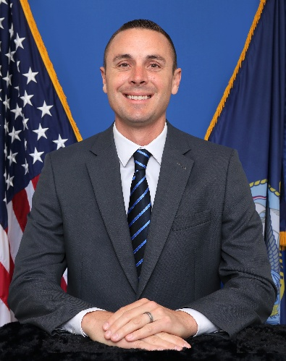


Blaine Summers

Naval Air Warfare Center

Aircraft Division Webster

Outlying Field

Executive Director,

Senior Scientific Technical Manager (SSTM)

Mr. Blaine Summers currently serves as the Executive Director of Naval Air Warfare Center Aircraft Division Webster Outlying Field (NAWCAD WOLF), an organization with a total obligational authority in excess of $1.4 billion that develops and delivers airborne, shipboard, and shore-based rapid, organic Lead Systems Integrator (oLSI) capability engineering solutions for Defense, Intelligence, and Homeland Security missions. He provides strategic leadership for roughly 3,500 people delivering capabilities all over the world.

In previous roles, Mr. Summers forged partnerships across the DoD, founding a Cross-Service Working Group to enhance collaboration and align DoD investments in mobile technologies. His efforts resulted in a multi-platform flight clearance to enable rapid fielding of modified commercial technology to over 40 Naval aviation platforms.

Mr. Summers also served as a leader in Unmanned Systems software development programs and as the Future Capabilities Lead in PMA-299, Multi-Mission Helicopters. He was responsible for warfare analysis, resource planning, and future capability development for multiple ACAT IC programs. He served a key leadership role in negotiating a $1.1B Capability Assurance Program with the Royal Australian Navy, establishing an international partnership to ensure continued investment in MH-60 tactical superiority.

Mr. Summers then served as NAVAIR’s Enterprise Deployment Lead for Systems Engineering Transformation. He was responsible for implementing digital engineering strategies across several Major Defense Acquisition Programs, leading an effort to transform Defense acquisition culture and dramatically increase the speed with which weapons systems are delivered to the fleet.

Mr. Summers most recently served as NAWCAD’s Director of Digital Transformation. He was responsible for transforming business and technical disciplines across a Warfare Center with over 10,000 personnel. He also served as the Director for the Joint Simulation Environment (JSE), leading a large cross-discipline team in the development of a high fidelity, Government-owned digital battlespace. JSE provides world- class training for F-35 Weapon Schools and operational squadrons.

Mr. Summers represented Navy equities in joint USN-USAF leadership forums, shaping multi-billion-dollar investments in support of warfighter needs.

Mr. Summers education includes a Bachelor of Science degree in Computer Engineering from the University of Maryland Baltimore County, a Master of Science degree in Engineering Management from the Florida Institute of Technology, and a Graduate Certificate in Cyber Warfare from the Naval Postgraduate School.

Mr. Summers was awarded the Department of the Navy’s Superior Civilian Service Award in December 2023.

