

CAPTAIN timothy lee castro

mission DIRECTOR NAVY RESERVES naval air systems command headquarters nas patuxent river md

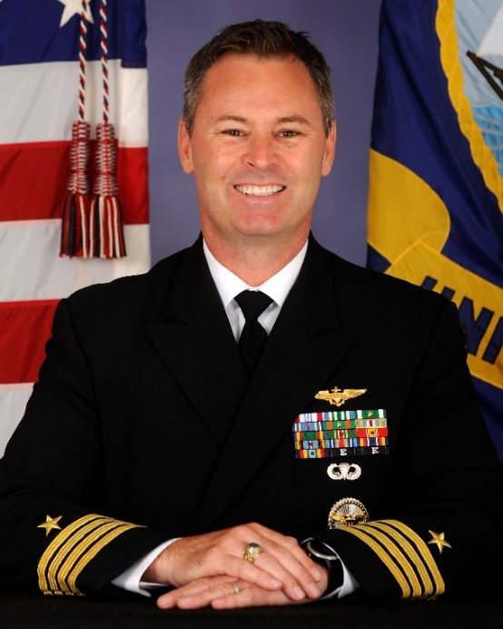
Capt. Tim Castro is the Military Director for Naval Air Warfare Center Aircraft Division Webster Outlying Field (NAWCAD WOLF). NAWCAD WOLF conducts the development, rapid prototyping, production, integration, and sustainment of warfighting capability while executing more than $1 billion of customer funds annually.
Castro started his Navy career in the enlisted ranks as a nuclear-qualified Machinist Mate. He is a graduate of United States Naval Academy in Annapolis Maryland, where he earned a Bachelor of Science degree in Ocean Engineering and received his commission in June 1997. He holds a Masters of Arts degree in National Security and Strategic Studies from the United States Naval War College in Newport, Rhode Island.
His active duty sea and shore tours as a naval aviator include Patrol Plane Captain and Mission Commander, Maritime Patrol and Reconnaissance Squadron Four Seven (VP-47), aide de camp to Commander Iceland Defense Force Island Command, and Catapult and Arresting Gear Officer and Hangar Bay Division Officer aboard the USS Harry S. Truman (CVN 75).
Castro left active duty September 2007 and served as senior marine engineer for air and ship integration supporting the Arleigh Burke Class Destroyer program office (PMS 400). He subsequently served as the air and ship integration contractor task lead for the Navy’s Next Generation Cruiser program office (PMS 501).
He joined the Navy Reserves in 2008 and was designated a C-130T Tactical Aircraft Commander as a member of the Capital Express of Fleet Logistics Support Squadron Five Three (VR-53). He completed multiple detachments and served as detachment Officer in Charge in Sigonella Italy, Atsugi, Japan, and Bahrain, where he completed numerous Navy Air Lift Office missions. During his time at VR-53, Castro served as the Aviation Safety Officer and as the Administrative, Safety, and Training department head at various times over an eight-year period.
In 2010, Castro transitioned to government civilian service serving as the integrated product team lead and lead system engineer for air and ship integration for the Zumwalt Class Destroyer program office (PMS 500). He subsequently served as the assistant program manager for systems engineering for increment 3 development of the P-8A aircraft in support of the Maritime Patrol and Reconnaissance Aircraft program office (PMA-290).
In 2015, Castro mobilized as an individual augmentee and served as the Officer in Charge for the Broad Area Maritime Surveillance Demonstrator in support of the Persistent Maritime Unmanned Aircraft Systems program office (PMA-262).
Castro served as the Executive Officer of Navy Reserve Secretary of Defense and Chief of Staff for the Deputy Assistant Secretary of Defense for Middle East policy at the Pentagon. He also served as the Deputy Director of Operations for Navy Reserve Fleet Forces Maritime Air Operations Detachment Joint Base McGuire-Dix-Lakehurst, New Jersey and as a Project Lead for various programs and Government Flight Representative for the Vanilla UAV program at the Office of Naval Research Reserve Component, Arlington, Virginia.
In 2017, Castro served as the class desk for the T-45 Physiological Episode integrated product team in support of the Naval Undergraduate Flight Training Systems Program Office (PMA-273).
Prior to his current assignment, Castro served as the assistant program manager for engineering for the Naval Air Traffic Management Systems program office (PMA-213).
Castro serves as the Mission Director and Project Lead for Wartime Readiness Planning for the Naval Reserve NAVAIR Headquarters Unit.
He is a recipient of the Defense Meritorious Service medal, Joint Service Commendation Medal, Navy and Marine Corps Commendation Medal, Joint Service Achievement Medal, Navy and Marine Corps Achievement Medal, and various unit and campaign awards.

